USER’S GUIDE

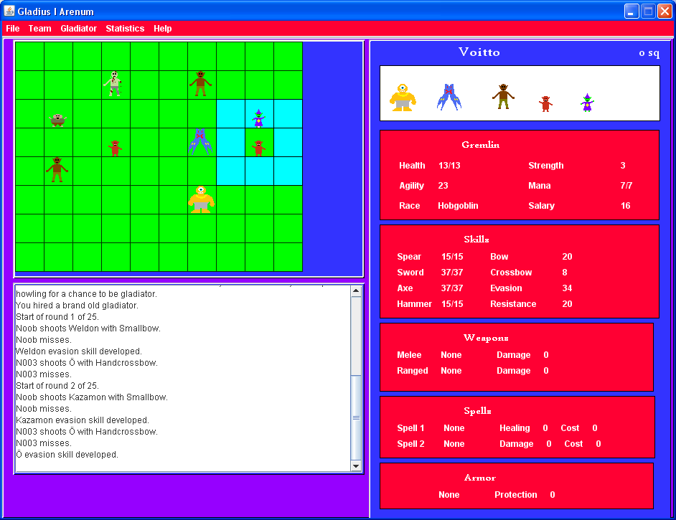

Playing the game

First you need to start a new game by selecting file and then new game. You’ll come to this screen:

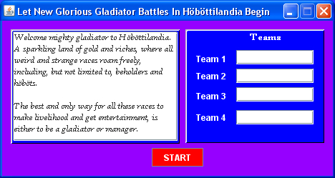

Here you can select how many human controlled teams there are by entering names for the teams. Blank name equals computer player here.

After you have entered team names and pressed start, you’ll get to the game’s main screen:
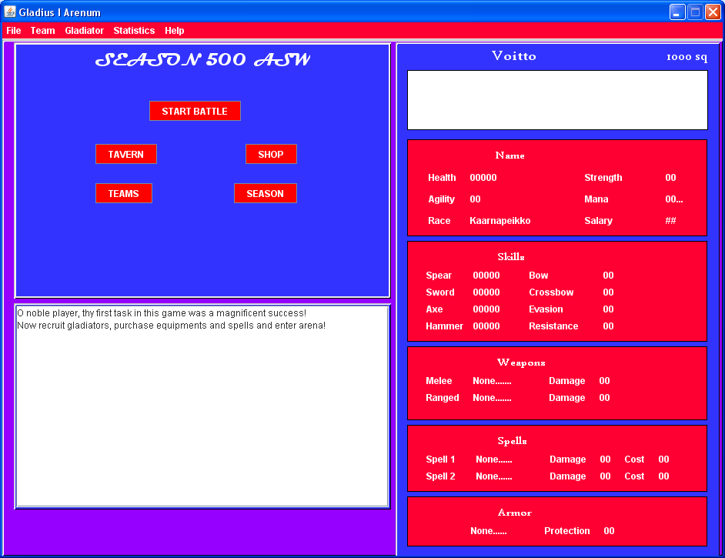
Here you’ll have access to three important places, tavern, shop and, last but not least, battle.

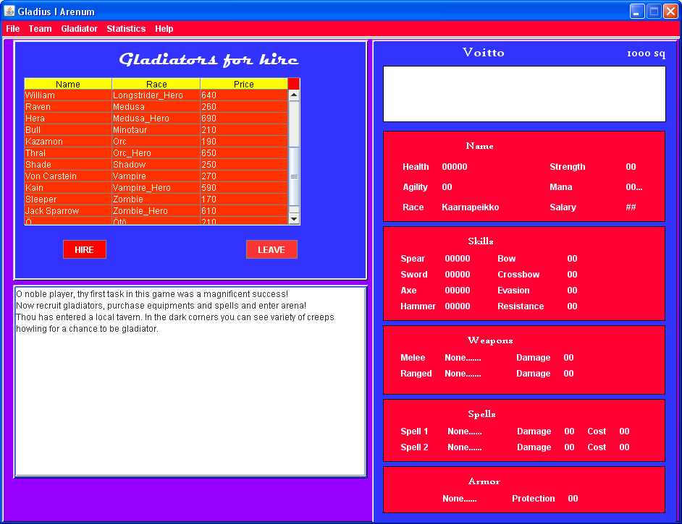

This is the tavern view. Here is where you must hire gladiators for your team. You can view the gladiator’s attributes and skills by clicking it. I recommend hiring only one or two gladiators at the beginning. You can hire rest of your team later when you have earned more squirrels.

Once you’ve done hiring, the next logical step is to go shopping.

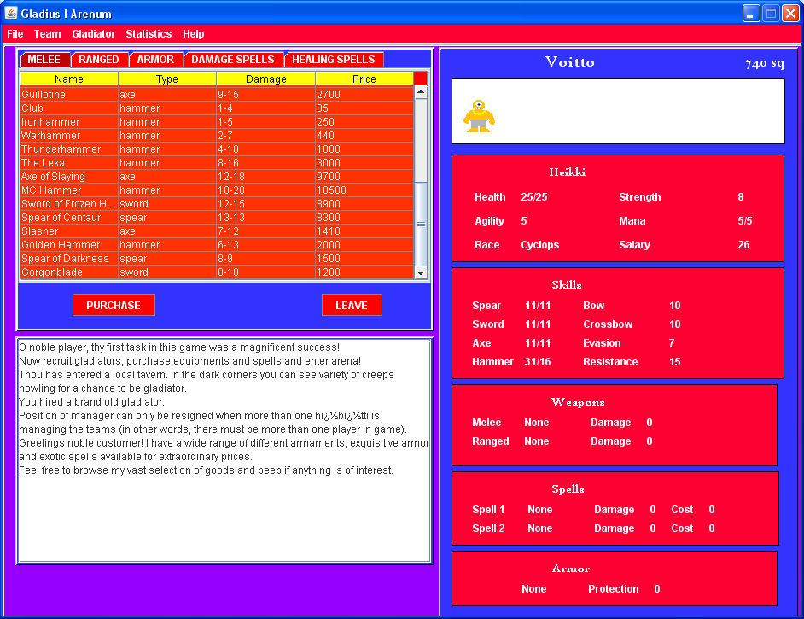

Here you can buy all the equipment and spells for your gladiator. Once you’ve finished with shopping it is time to enter the arena.

Arena

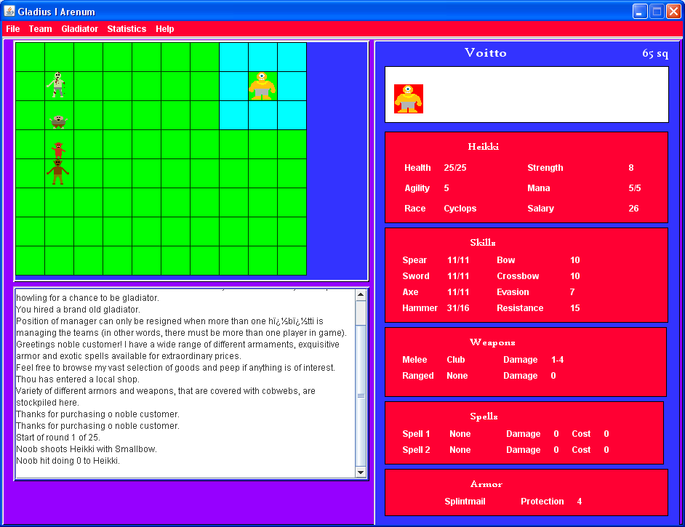

This is the battle screen. On the left side you can see computer controlled team, Newbies and on the right side is Heikki. It is Heikki’s turn and he’s ready to rumble. However, since he has no ranged weapon like Noob did, he has to move towards enemy gladiators. Teal squares indicate the places where gladiator can move. If a teal square is occupied by enemy gladiator then you can attack him/her/it. On the other hand, If the teal square is occupied by friendly gladiator, and you click it, the gladiators will swap places.

YOU CAN USE BOTH MOUSE AND NUMPAD KEYS FOR MOVEMENT.

Pressing num-pad key 5 or clicking gladiator with left-mouse button will make gladiator pass the turn. If you click any gladiator with right-mouse button, game will show the stats of the clicked gladiator. If you have ranged weapon or damage spell, you can hit opposing gladiators from a far by just clicking left mouse button. In the case you have both damage spell and ranged weapon, you can choose to use the spell by clicking middle mouse button. You can’t use ranged weapon or spell on enemy gladiator that is next to you: your gladiator will perform melee attack.
If you have healing spell, you can heal a friendly gladiator by left clicking him/her/it provided the gladiator isn’t adjacent to you or unconscious.

Successful attacks that do damage are indicated by blood marks. Attacks that miss or won’t do any damage are indicated by light-blue sphere. Successful attacks or defends have a chance to increase gladiator’s skills. If gladiator is unconscious, having reduced to 0 or less health, he will be marked by brown blood mark.

Battle ends if members of either team are all unconscious or the round limit 25 is reached. After the battle you earn some squirrels and pay your gladiators’ upkeep.

RACES

Beholder
Attacks with beholder rays, Beholders can’t wear any equipments, but they are good spell casters, have ranged attack and natural armor of 4.
Cyclops
Cyclops are tough brutes, who excel fighting with hammers and have natural armor of 1.
GoblinWizard:
Best spell caster in game, not useful for much else.
Hobgoblin:
Small and cheap, what more is here to tell?
Höbötti:
Fat, cowardly höbötts are pretty good with crossbows.
Kaarnapeikko:
No race can endure as much punishment as armored kaarnapeikko with their great health and natural armor of 1. They are best hired early so that their lacking weapon skills have chance to evolve.
Longstrider:
They are good with spears.
Medusa:
You wouldn’t probably marry her, but they are solid in arena.
Minotaur:
Minotaurs are excellent melee fighters who can wield both axes and hammers with ease.
Orc:
Average please.
Shadow:
If you have two shadows, the chances are that another of them is this guy.
Vampire:
It is really a pity that vampires are prohibited from sucking the blood of their preys in arena combat. On the other hand, they’ll have a nice höböt-sandwich after the battle.
Zombie
Your average horror movie foe.
Ötö
Weird race emerging from the smoky depths of caramel pits. Not much else is known except they are solid spell casters.

PS. Jos osaat lukea suomea, kannattaa ehdottomasti kokeilla Areena-sarjan pelejä jotka ovat enemmän kuin inspiroineet tätä koulutyötä.

